📊 Exploratory Data Analysis (EDA) Report

1. Title Page
- Project Title: Exploratory Data Analysis Dashboard
- Dataset: Cleaned Cola Dataset (Week 1 output)
- Prepared By: Ishika

2. Abstract
- Short summary of the project.
- Mention that the dataset was cleaned in Week 1 and analyzed in Week 2.
- State the purpose: to identify patterns, trends, and relationships using descriptive statistics and visualizations.

3. Introduction
- Background of the dataset (source, type of data).
- Why EDA is important.
- Objectives of this analysis:
  - Perform descriptive statistics.
  - Identify trends and relationships.
  - Create clear visualizations.
  - Summarize meaningful insights.

4. Tools and Libraries Used
- Python
- pandas – for data manipulation and descriptive statistics
- matplotlib – for basic plotting
- seaborn – for advanced visualizations

5. Dataset Overview
- Shape of dataset (rows × columns).
- Data types of variables.
- Missing values check.
- Short description of each column (e.g., year, value, in_million_usd).

6. Descriptive Statistics
- Summary statistics (mean, median, min, max, std).
- Frequency counts for categorical variables.
- Key highlights (e.g., average value, range of years).

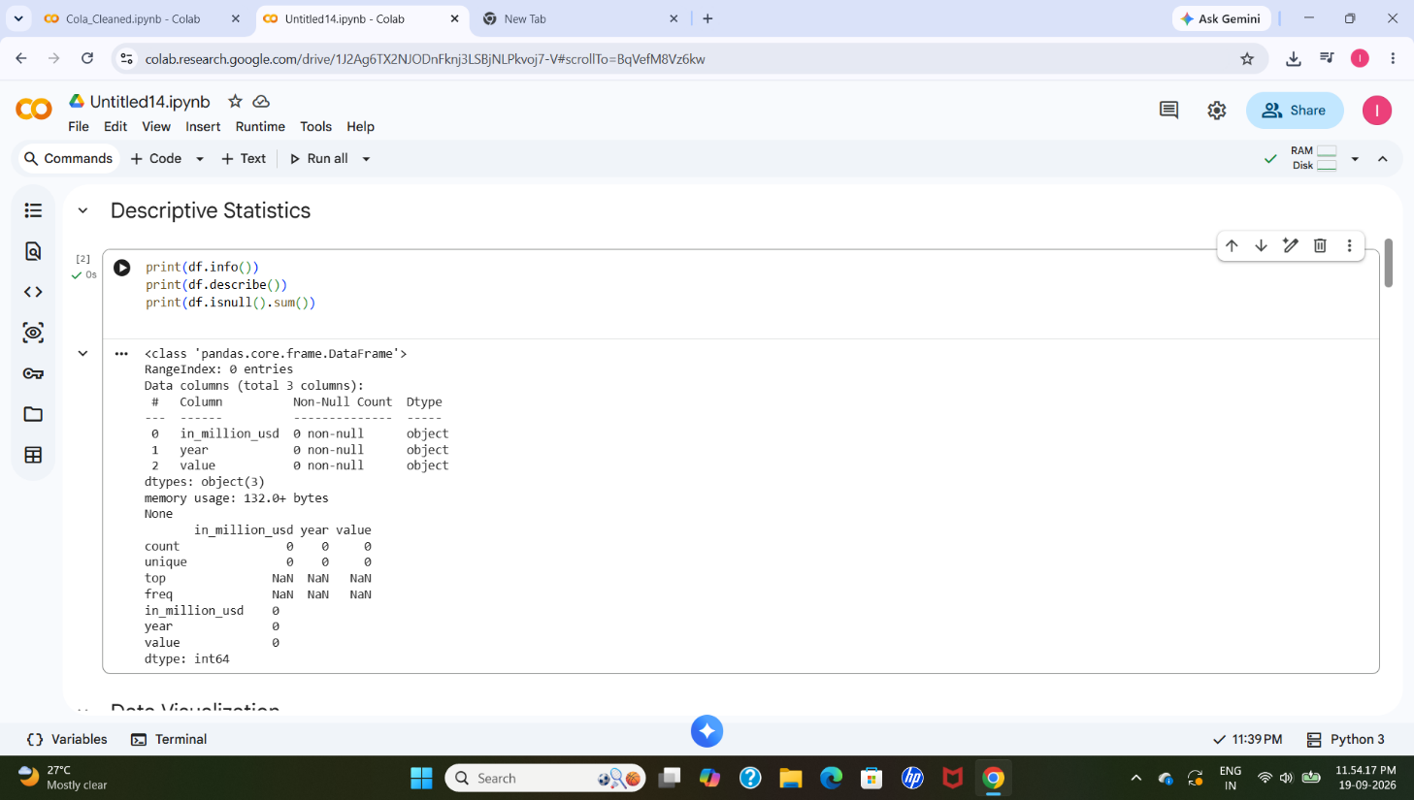

7. Data Visualizations
Insert screenshots of each chart with captions:
- Histogram – Distribution of values.
  - Observation: Value distribution is right-skewed.
- Boxplot – Outlier detection.
  - Observation: Outliers exist in the value column.
- Line Plot – Trend over years.
  - Observation: Steady growth with decline in certain years.
- Bar Chart – Category comparison.
  - Observation: Certain categories contribute disproportionately.
- Heatmap – Correlation matrix.
  - Observation: Strong correlation between key variables.

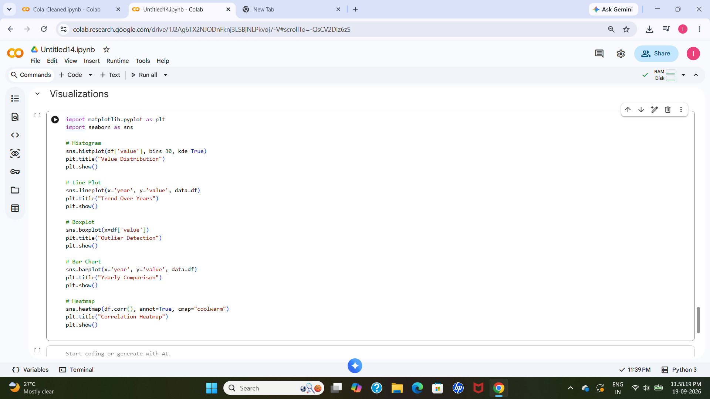

8. Observations
- Value distribution is right-skewed.
- Year shows steady growth with some decline in later years.
- Outliers exist in the value column.
- Certain categories/years contribute disproportionately.
- Strong correlation observed between variables.

9. Conclusion
- This EDA helped us understand important dataset patterns.
- Distribution and outliers were identified.
- Trends over time and category comparisons became clear.
- Correlation matrix revealed relationships between variables.
- These insights will be useful for future analysis and decision-making.

10. References
- pandas Documentation
- Matplotlib Documentation (matplotlib.org in Bing)
- Seaborn Documentation
- Dataset: Cleaned Cola Dataset (Week 1 output)

